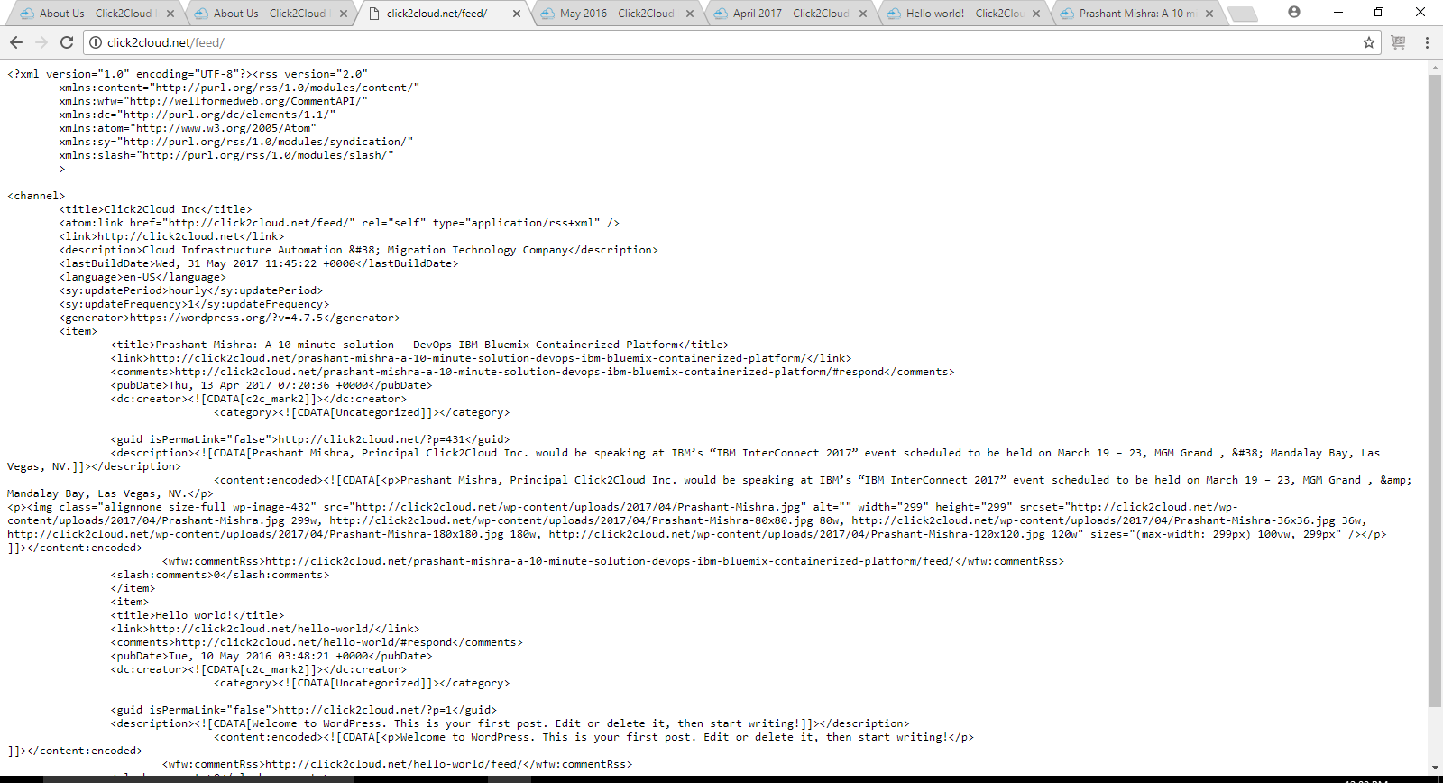

1. Go to MORE-> RSS -> Enterprise RSS

Go to MORE-> RSS ->Comments RSS

It displays you the code page.

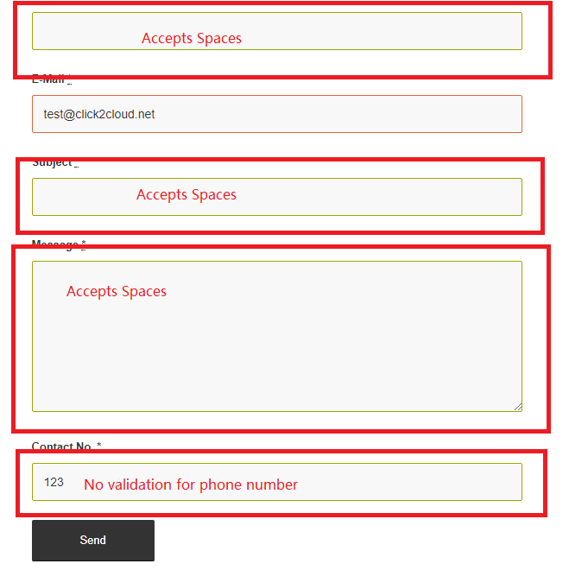

1. Go to CONTACT US-> It accepts the email details with all the spaces in the text box.

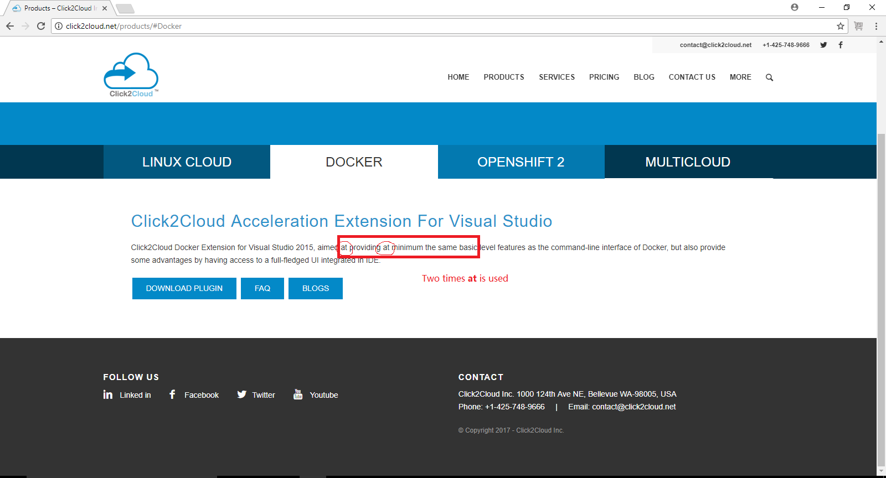

1. Go to -> PRODUCTS->DOCKER

It contains **at** keyword 2 times.

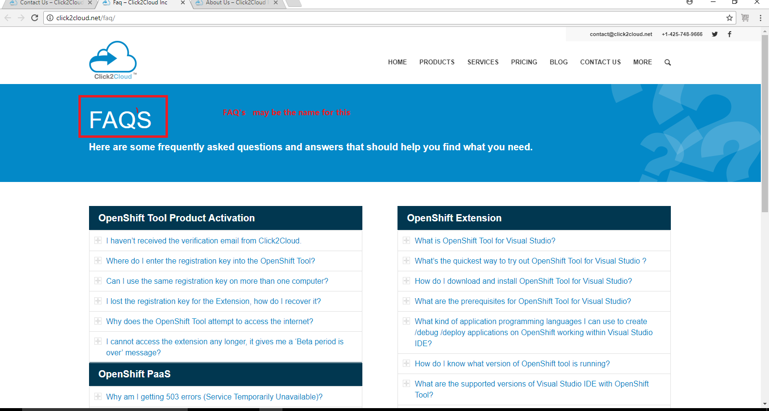

1. Can’t we write FAQ as FAQ’s

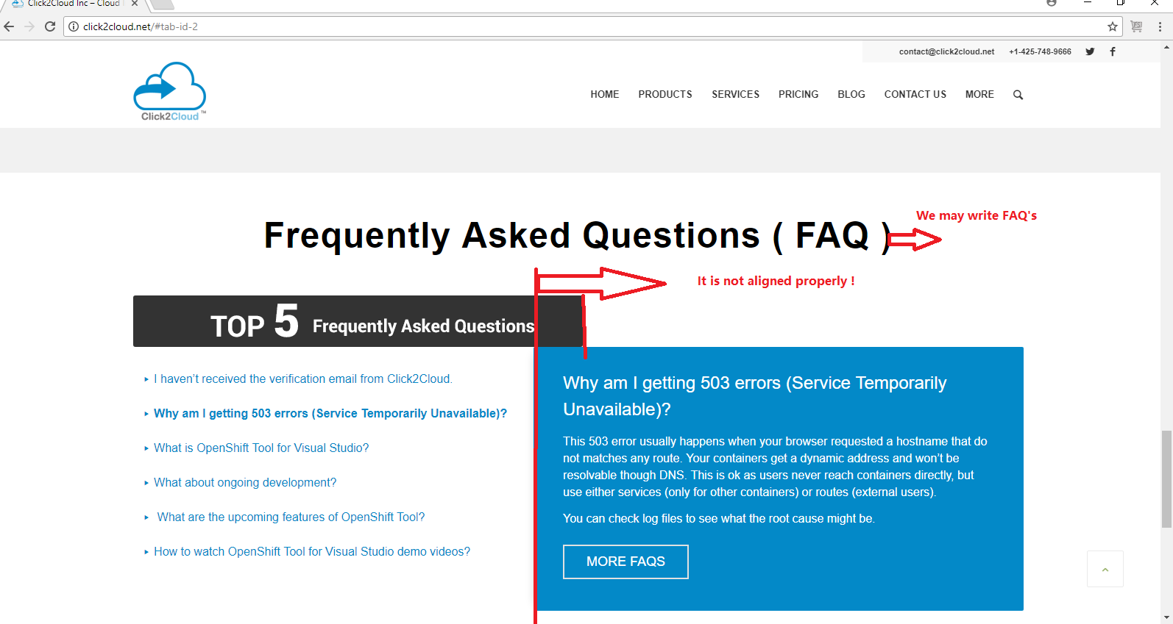

1. Can we write FAQ as FAQ’s

And both the things are not properly aligned.

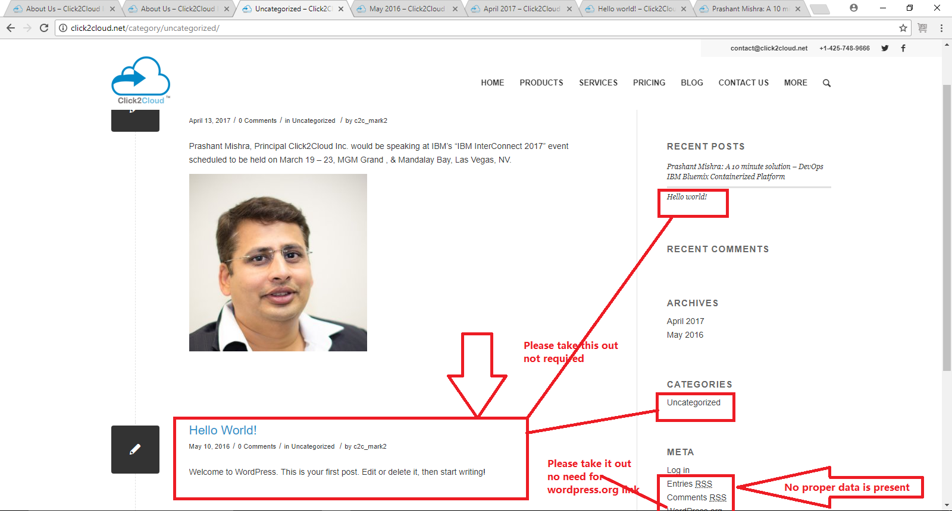

1. Take out Hello world contents, Uncategorised, Log in, Entries RSS, Comments RSS, Wordpress.org

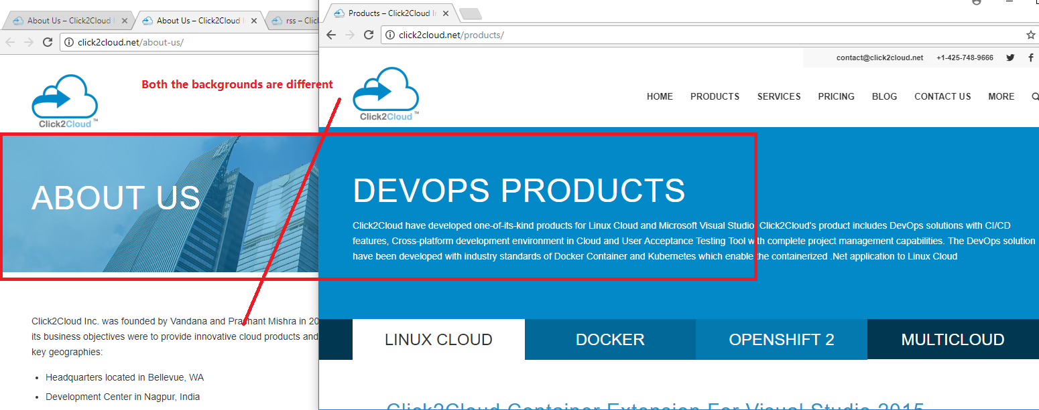

1. On both pages the background images are different.

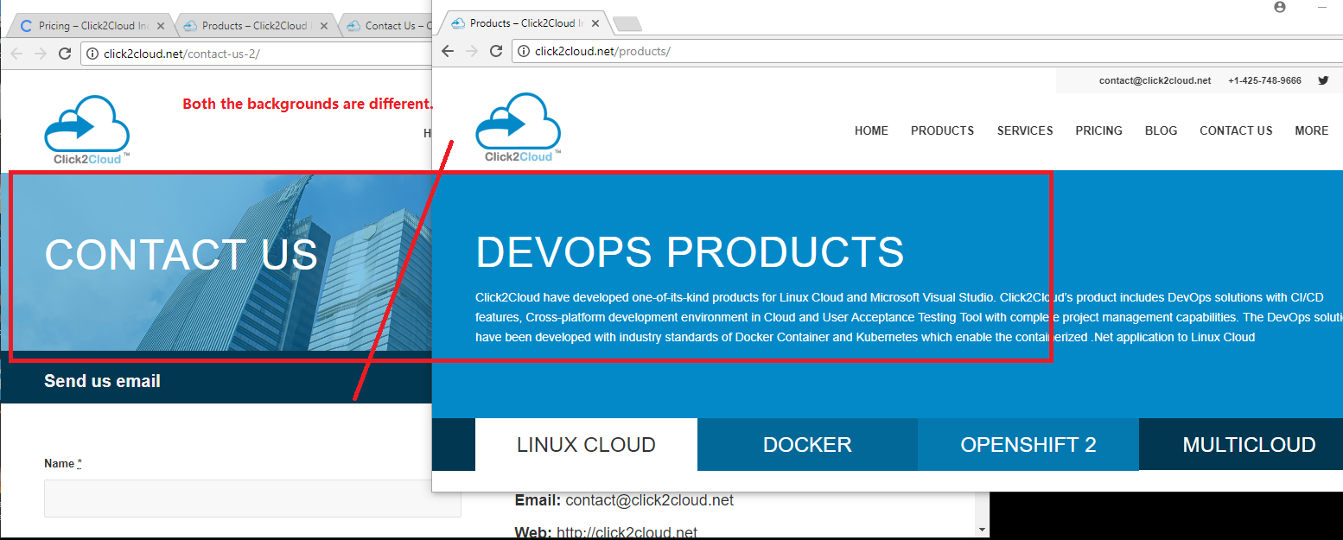

1. On both pages the background images are different.

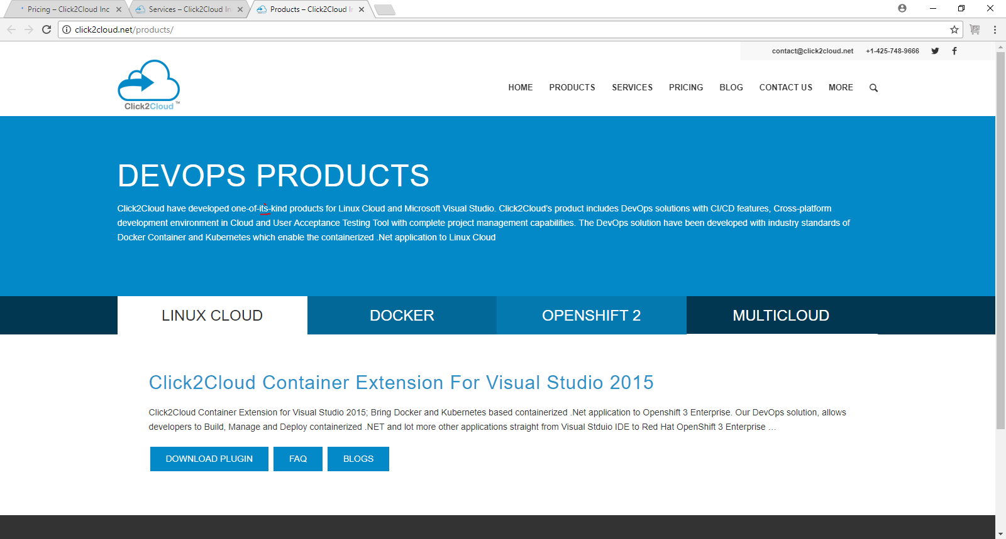

1. Can we write it’s instead of its?

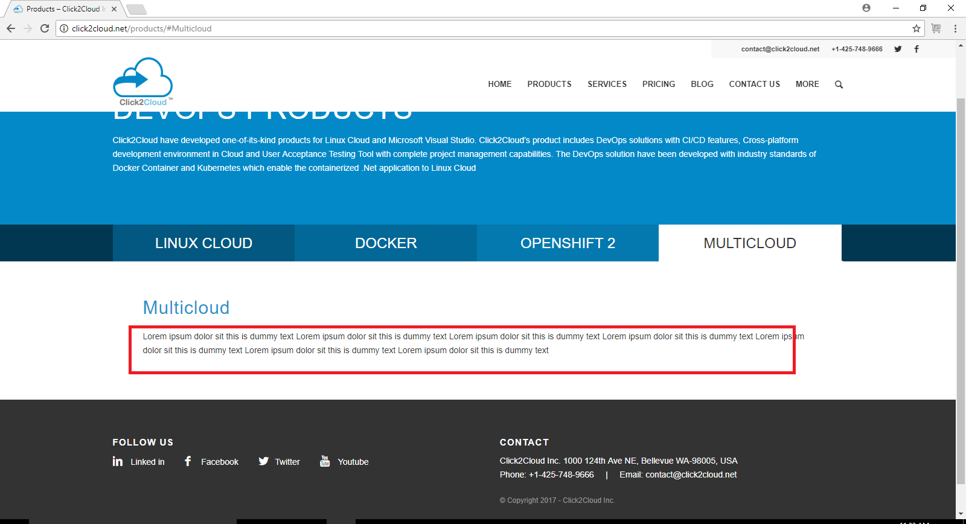

1. Go to PRODUCTS->MULTICLOUD :-> The **lorem ipsum** is written all over on this page.

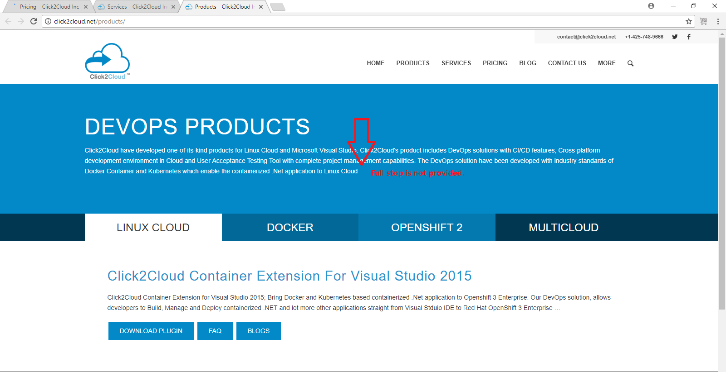

1. Go to PRODUCTS-> Here at last of the description of DEVOPS PRODUCTS no full stop is provided.

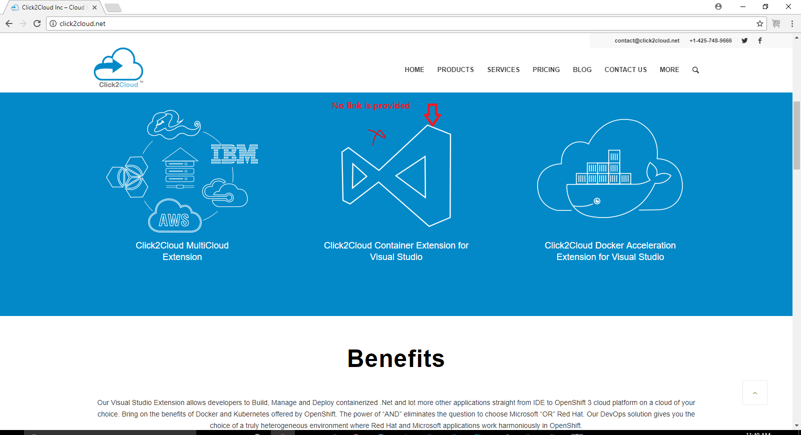

1. Go to HOME page -> On click2cloud container extension for visual studio **no link is provided.**

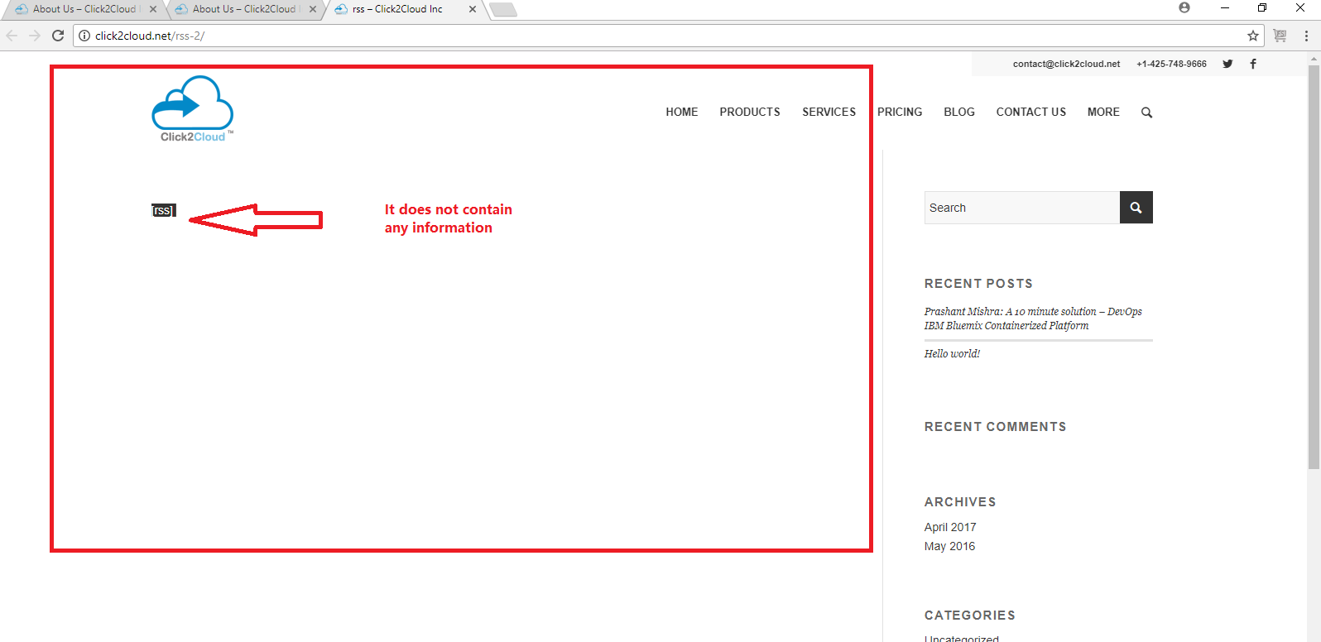

1. Go to -> MORE-RSS :-> Here only the name rss is written no data is present.

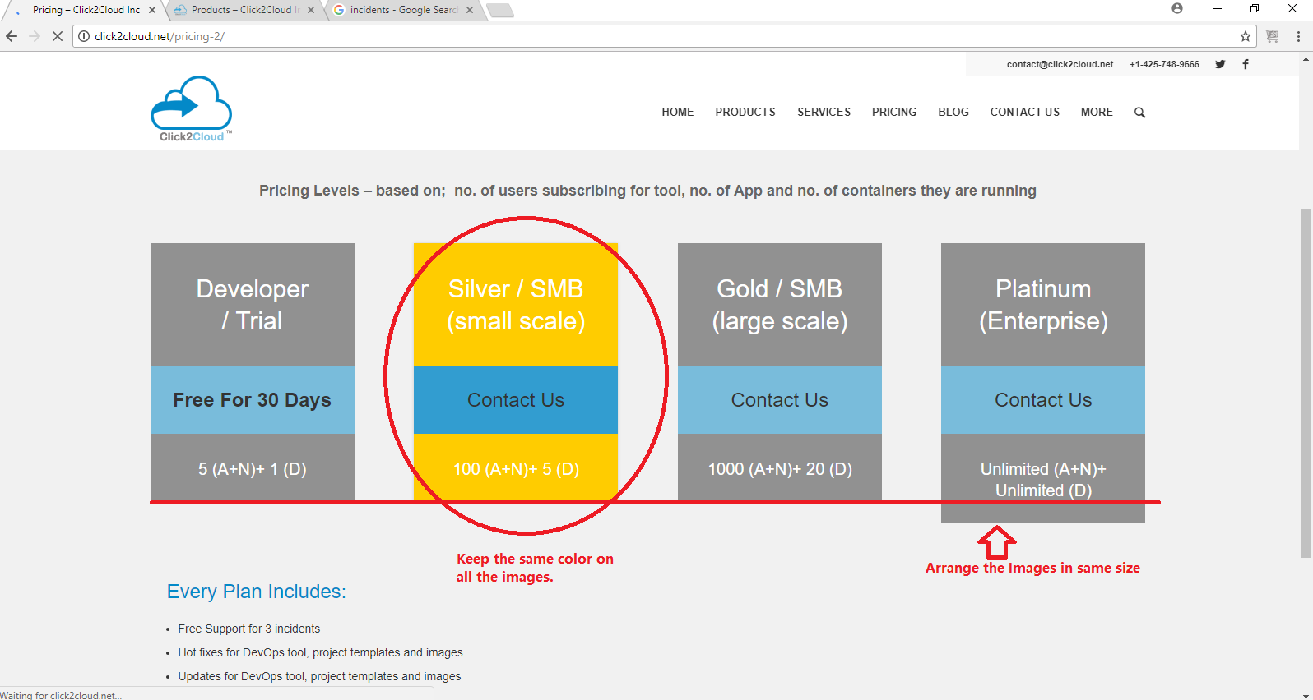

1. Go to -> PRICING-> Here whey the second option is in yellow color ?

The last option is not properly aligned.

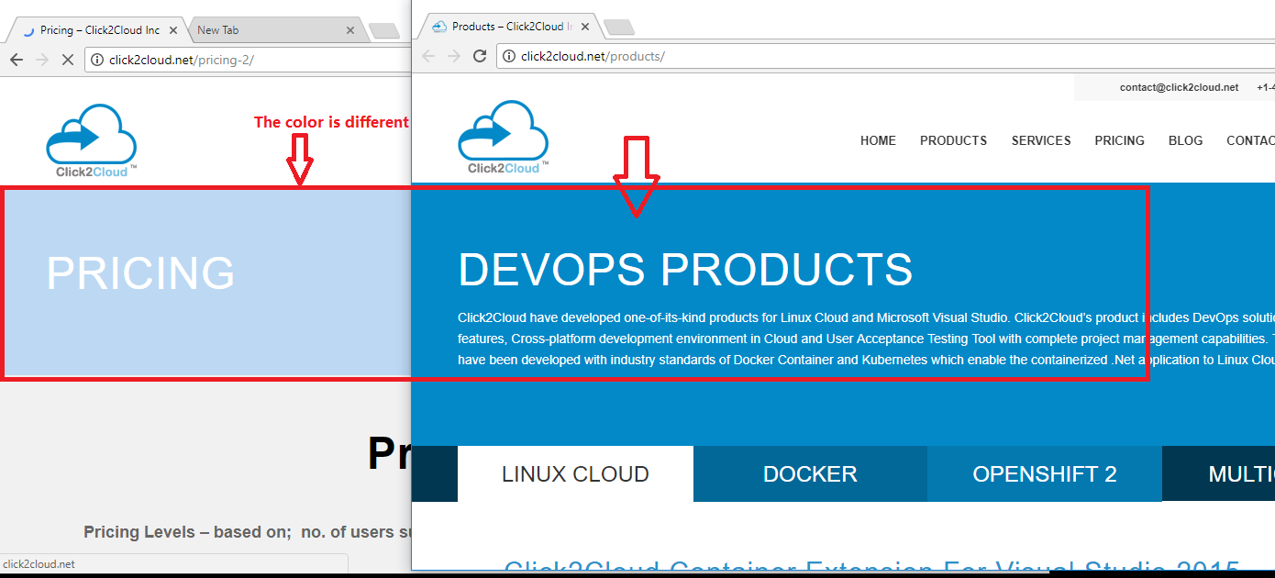

1. Go to->PRICING -> The background color is not matching with other pages.

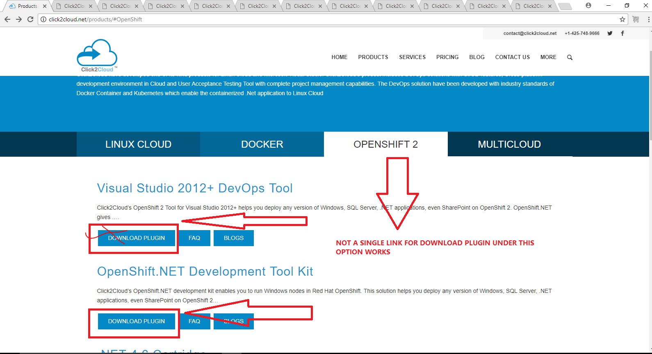

1. Go to PRODUCTS -> OPENSHIFT 2-> Here for DOWNLOAD PLUGIN OPTION no link is provided throughout the page.

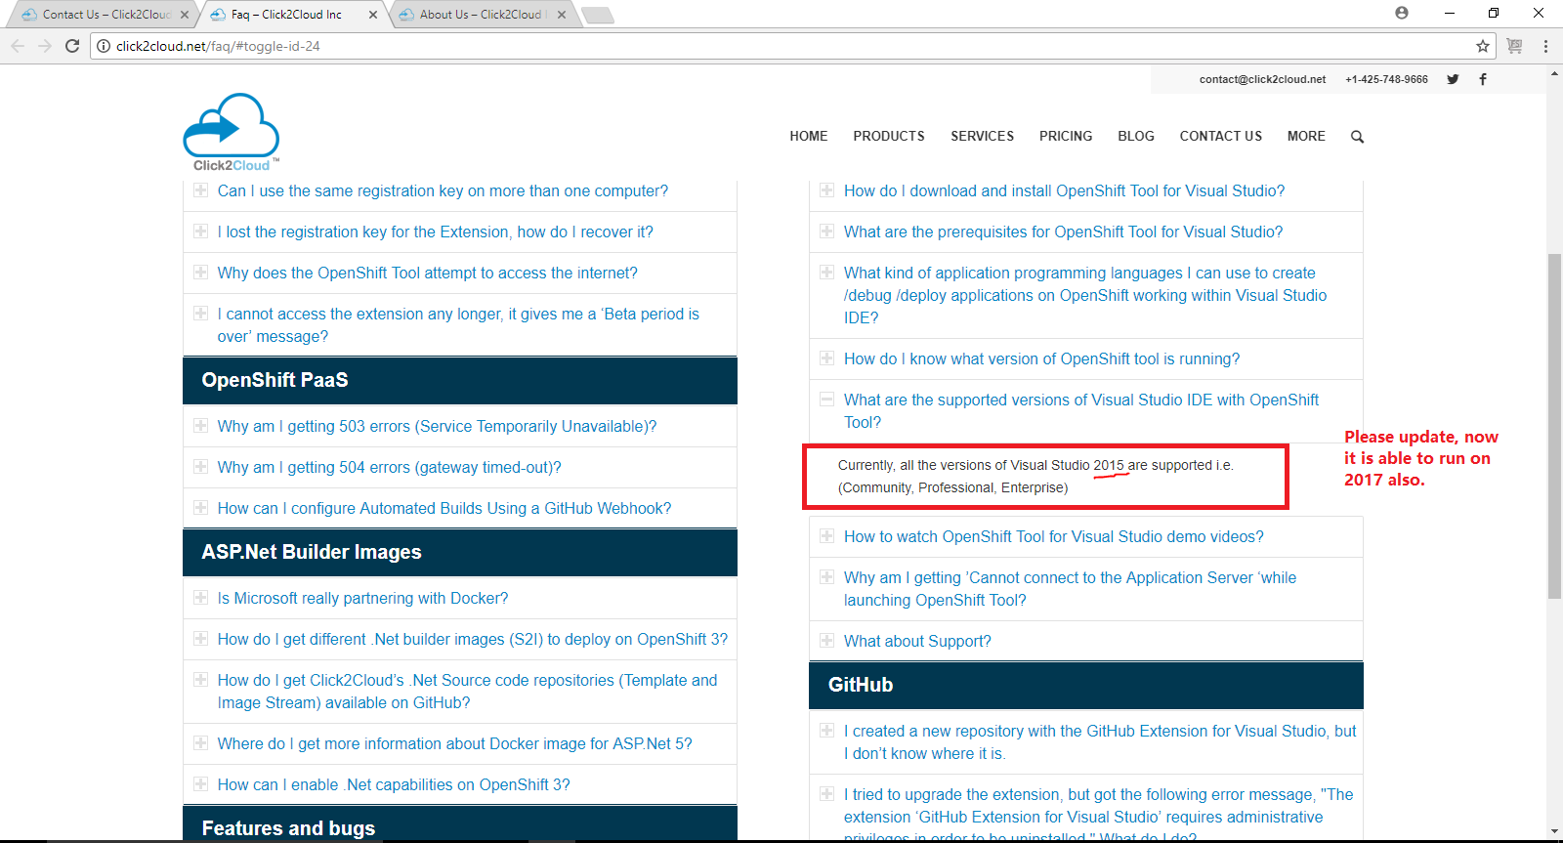

1. Go to MORE-> FAQ-> Here please update the version of visual studio to 2017, now our openshift plugin supports 2017 version of visual studio.

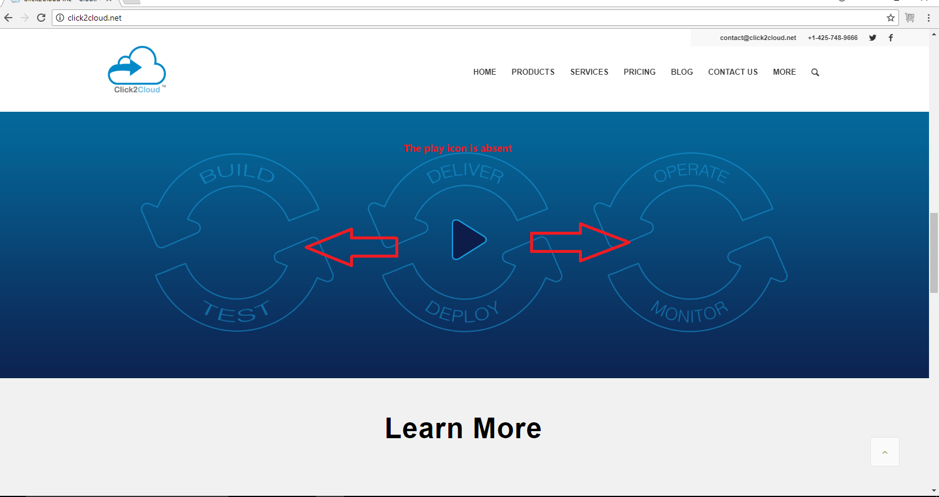

1. GO to HOME page -> Here for first and last option no play button is provided, As it is available in the middle option.

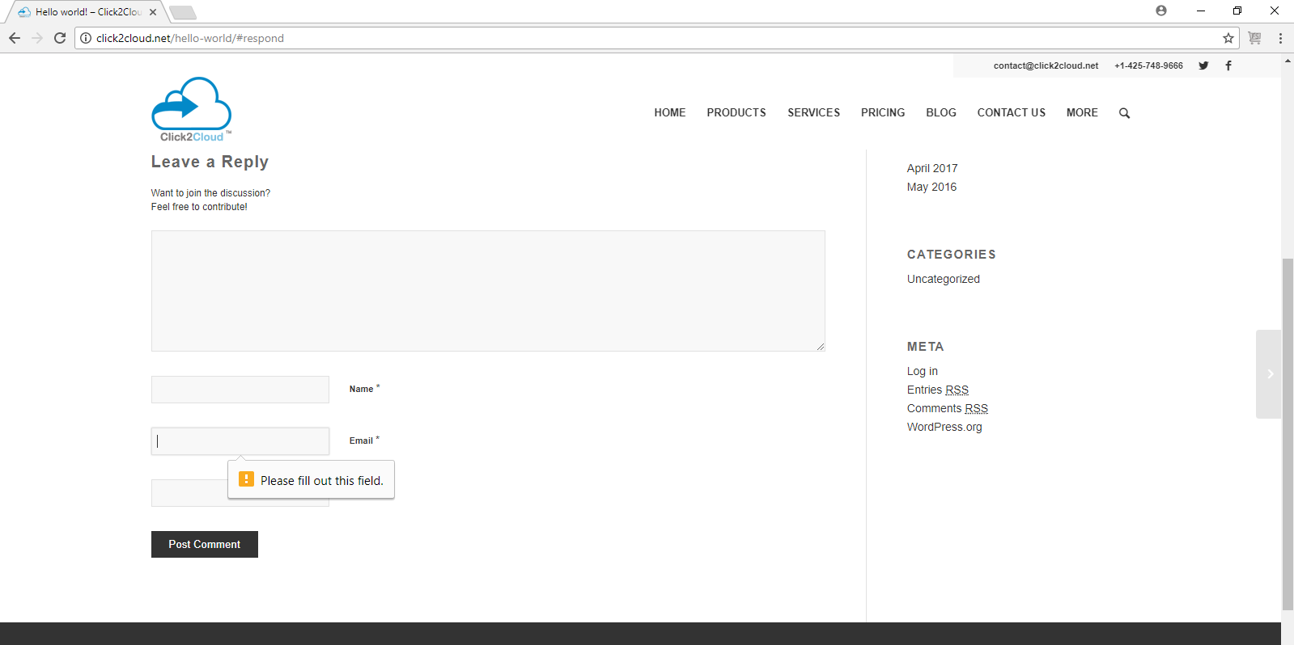

1. Go to MORE->RSS->CATEGORIES->Uncategorized-> Here when you try to reply the news feed, The text boxes accepts blank spaces.

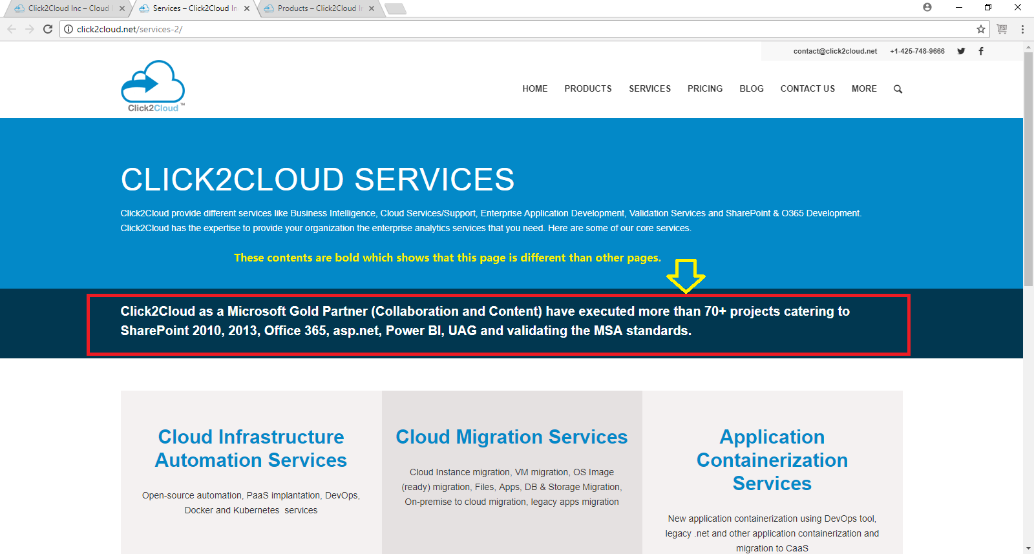

1. Go to Services-> Here the marked box’s contents are bold, please keep it simple.
2. The website behaves very slow when loaded first time on the browser.
3. Clicking on [support@click2cloud.net](mailto:support@click2cloud.net) and [contact@click2cloud.net](mailto:contact@click2cloud.net) doesn’t pop-up the outlook’s compose email option.